**Module -3   
 Technology & Standards for Geospatial workflow**

**Project Proposal**

**Aim –** Creating Dash board to draw attention towards awareness regarding real word problem.  
  
**Research Gap -**   
Data pre-treatment, analysis, and visualisation are just a few of the complicated and repetitive processes that frequently go into geospatial workflows. Geospatial workflows usually include repetitive and complex tasks including data preparation, processing, and visualisation. Geospatial data frequently has inaccuracies and uncertainties, which can affect how reliable and accurate analysis and decision-making are.

**Research Question-**   
 i) Research is done for the creating dashboard but for better understanding and user friendly consider  
 the user’s needs, preferences, and behaviour.  
ii) How can a user personalize and customize there task according to requirement.  
iii) Effectiveness and efficiency of dashboard and how it can be measured in real time.

**Sub- Objectives -**  
 i) To find data portal and making short accessible by APIs keys   
 ii) Creating database/ data frame for visualizing (creating plot and graphs)  
 iii)Creating Dashboard to spread awareness.  
  
  
**Methodology-**  
Identifying an issue and choosing it in accordance with the criteria. Then, to fulfil the criteria, searching the dataset from the open data portal. gaining access to the dataset using API tools for further research. either building a database on the cloud or using a straight command to request one. employing programming language to create the dash board. collecting user input while displaying the board on the internet. difficulty is resolved, and as a result, society's consciousness is growing.

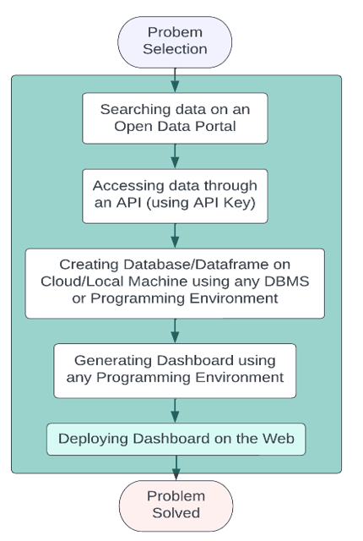

Figure1 Workflow diagram

**Expected Result –** By creating a dashboard, one may visualise a dataset, raise awareness of it, and make it easier for people to interpret its plots and graphs.

**Submitted By -**  
Aakanksha S. Borkar (GSD)  
Disha Yadav (URSD)  
Shikha Gupta (GID)